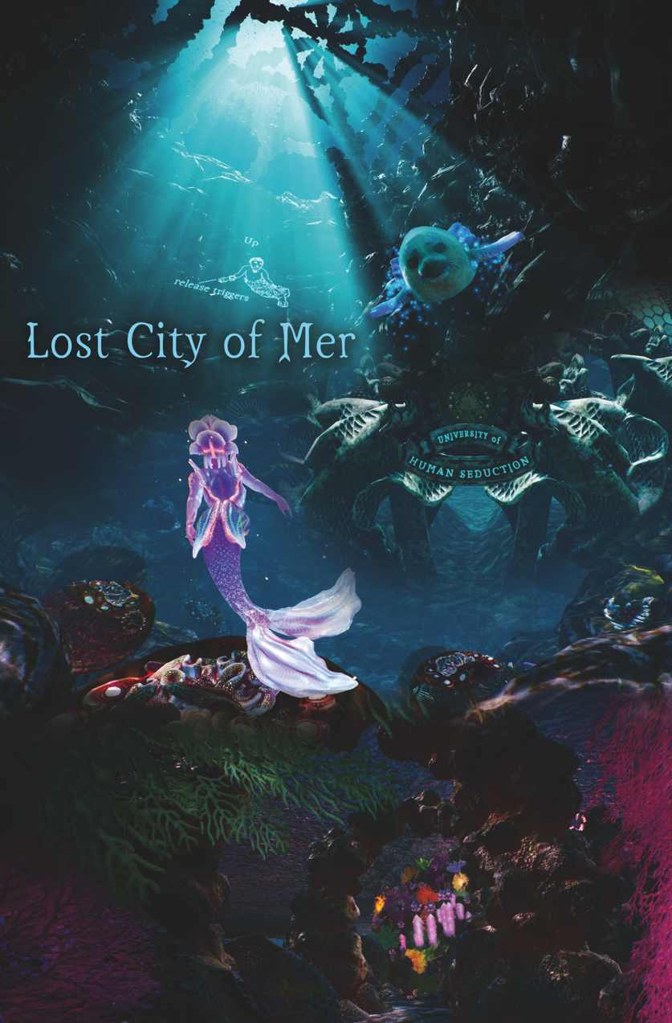

Lost City of Mer: Chapter 1
Producer/Director/Writer: Liz Canner
Co-Producer/Co-Director/Animator: Gregory Bennett
www.lostcityofmer.org
Contact: Liz Canner
Phone: (617) 733 – 8426
Email: lizcanner@astreamedia.org

Logline
Innovative “swimming” navigation, game play, elements of sci-fi and mystery inspire users to reduce their carbon footprint in the real world in order to restore a magical lost civilization in the virtual world.

Challenge
The mysterious underwater Mer civilization and much of its flora and fauna have been destroyed. Only spirit creatures remain. You are the first Mer (maid) born in decades. Athina, a baby seal spirit, befriends you and takes you on a journey through the remnants of the stunning, complex Mer metropolis, hoping that you will resurrect the collapsed ecosystem. You witness the devastation caused by climate change and other environmental hazards. Will you take the necessary steps to generate new life and win rewards to revive the natural splendor of Mer and her otherworldly inhabitants?

Synopsis
Lost City of Mer: Chapter 1 is an innovative interactive cross-platform VR and mobile app experience that immerses the player in a magical undersea civilization devastated by climate change. The player is the last Mer baby in a dying ocean. The rest of the Mer(maids) are extinct. Guided by a lonesome seal spirit, the player explores the ruined metropolis, tends to secret gardens of coral threatened by pollution, and plants coral to revive the Mer(maids), in the process learning the impact of their real world actions. Lost City Of Mer represents an innovative approach to climate change awareness, one that spurs action by showing the beauty of our real and mythical creatures, and the stakes of our neglect.

The project was created by Astrea Media, a US nonprofit organization, in collaboration with Auckland University of Technology in New Zealand. It was developed with the input of environmental scientists from Harvard University and Dartmouth College. The experience is based on real science, but told through fantasy, as it draws on the cross-cultural myth of the mermaid to appeal to people across the globe. It will be available in over 20 languages and distributed internationally to VR arcades, schools, museums, aquariums, film festivals, international NGOs, the United Nations, community centers, libraries, conferences, religious organizations, .

The colorful palette and dreamy sci-fi aesthetic of Mer shows not just devastation, but the splendor and wonder of a world worth fighting for-- and provides the tools to do it. The otherworldly architecture of the city was inspired by the work of Antoni Gaudi and Georgia O’Keefe. The stunning coral gardens reference Claude Monet’s garden at Giverny, and Butchart Gardens in Canada.

Lost City of Mer utilizes a groundbreaking living narrative structure where the audience’s real world actions impact the story that unfolds. The accompanying phone app, for Apple and Android phones, extends game-play to the user’s everyday life by challenging them to lower their carbon footprint, in order to resurrect Mer and keep Athina alive. In the process, they will learn about of their own impact on the environment and will be provided with an educational and entertaining tool to mitigate their carbon footprint. The app will incentivize and reward strategies such as lowering the use of single plastics, walking or taking public transportation instead of driving, and choosing a plant-based diet.

Coral reefs are the most majestic gardens on earth, and support a quarter of ocean species. It is estimated that by 2050, if drastic measures aren't taken, 90% of them will be gone. Lost City of Mer will hopefully educate thousands of people about the beauty and importance of the reefs and inspire and incentivize them to take action.

Key Production Personnel Bios
Liz Canner – Director/writer/producer:
Liz Canner is an award-winning filmmaker, digital artist, sculptor, and writer who creates films, cross-platform digital media projects, and installations intended to inspire positive change. She likes to employ cutting-edge technologies to explore human rights and environmental issues from a new perspective. A prime example of this is her critically acclaimed public cyber art documentary Symphony of a City on the housing crisis. Her feature documentary Orgasm Inc., a New York Times “Critics’ Pick”, about the pharmaceutical industry and women’s health played at over a 100 film festivals internationally, was theatrically released, broadcast on many TV stations globally, and streamed on sites such as Sundance Now, Netflix internationally (“Most Popular” in “Critically Acclaimed” and “Social and Cultural Documentaries” in 2011 and 2012) and Kanopy (“Most Popular” in “Science, Nature & Technology”, “Medicine”, “Feminism”, “Biology”, “Health & Wellness”, “Advertising”, “Consumerism”, “Pharmaceuticals” and “Sexuality” in 2018 and 2019)

A graduate of Brown University with Honors in both Visual Arts and Anthropology, she has received over 60 awards and grants for her work including a Radcliffe Institute for Advanced Study Fellowship from Harvard University, a Rockefeller Foundation Next Generation Leadership Fellowship, a National Endowment for the Arts grant and the Dartmouth College Visionary Award. Her documentaries have broadcast on television on PBS stations, cable, and internationally in many countries. Her media art projects have shown at museums and galleries including Boston's Institute of Contemporary Art, The Museum of Fine Arts, Boston, and the California Museum of Photography. She has given over 150 talks about her work at universities, museums and screening venues. Committed to helping other independent filmmakers, she served on the board of directors of The Association of Independent Video and Filmmakers, the Boston Film and Video Foundation, Boston Cyberarts and White River Indie Films. She is the founder and director of Astrea Media Inc., a nonprofit media company dedicated to creating innovative projects on human rights and environmental issues.

Gregory Bennett - Co-director/co-producer/animator:
Gregory Bennett is a New Zealand-based digital artist who works with 3D animation, motion capture, projection mapping, virtual and augmented reality and interactive media. He has exhibited internationally in New Zealand, Australia, the USA, and Europe, and his work is represented in both public and private collections. Recent exhibitions include the real-fake.org.2.0, a survey of international digital artists at the BronxArtSpace in New York, the juried exhibition at the 2016 International Symposium on Electronic Art in Hong Kong, and the Supernova 2017 Digital Animation Festival in Denver. He is currently Head of Department for Digital Design and Visual Arts at Auckland University of Technology.

Project Advisors
Alex Barnett – Scientific Advisor:
Alex Barnett is an applied mathematician and numerical analyst. He was a Professor in the mathematics department at Dartmouth College for 12 years. He attended Cambridge University and obtained his Ph.D. in physics at Harvard University, followed by a postdoctoral fellowship in radiology at Massachusetts General Hospital and a Courant Instructorship at New York University. His research interests include scientific computing, partial differential equations, integral equations, biomedical imaging, neuroscience, inverse problems, and quantum chaos. Barnett is well known for numerical work in wave scattering, high-frequency eigenvalues, potential theory, periodic geometries, and fast algorithms. He has received several grants from the National Science Foundation, received Dartmouth’s Karen E. Wetterhahn Memorial Award for Distinguished Creative or Scholarly Achievement, and won the XXI International Physics Olympiad.

Winslow Burleson – Advisor
Winslow Burleson, a professor at New York University, leads the NYU-X Lab he is developing a transdisciplinary research and innovation holodeck. Win was recognized by the National Academy of Engineering (NAE) as “one of the nation’s leading engineering researchers and educators”. He received the best paper award at the 2009 International Conference on Artificial Intelligence, the field’s top conference, showing Affective Learning Companions’ ability to have a large-scale societal impact on thousands of students, by bringing cyber-enabled learning research into classroom settings. Win has been awarded 10 patents, four inventor and innovator awards from IBM Research, two Time Magazine Awards for the top 10 and top 50 inventions of the year, authored over 100 scientific publications, exhibited at the Pompidou Centre, and performed in Carnegie Hall.

Paul Moorcroft – Scientific Advisor
Paul Moorcroft, a professor at the Harvard University Center for the Environment, has done extensive research on the impact of climate change. He uses mathematical models to study ecological dynamics of terrestrial plant communities and ecosystems and biosphere-atmosphere interactions.

DG Webster – Scientific Advisor:
DG Webster, a professor of Environmental Studies at Dartmouth College, focuses her research on understanding feedbacks within global scale social-ecological systems. Primarily, her work looks at the impact humans have on the oceans. Currently, she’s studying coral reefs.

Marc Weiss – Advisor:
Marc Weiss is the creator of the celebrated PBS series P.O.V., a climate educator and former board member of the Sierra Club Foundation. He has been a leader in the independent media movement for more than 40 years, first as a filmmaker and journalist, then as a co-founder of several key organizations including Web Lab, an online laboratory that uses the Internet to engage a wide range of people on important issues.

Dives in Lost City of Mer

9th Annual New York Videogame Awards: celebration and ceremony dives, The New York Videogame Critic Circle, SVA Theatre, New York City. January 21st, 2020.

Virtual Reality and Environmental Storytelling Festival: dive and invited talk, The University of Pennsylvania, Philadelphia, PA. November 22nd, 2019.

SIGGRAPH Asia, International Premier, Winner: 2nd place for Best XR Content, Brisbane, Australia. November 17th – 20th, 2019.

Champlain College: Dive and invited talk, Burlington, VT. October 21st, 2019.

The Media Factory, VR for social impact workshop with Lost City of Mer, Burlington, VT. October 18th, 2019.

Vermont International Film Festival, Burlington, VT. October 19th – 20th, 2019.

United Nations General Assembly Climate Summit, SDG Action Zone dives during the General Assembly Climate Summit, United Nations, New York City. September 23rd, 2019.

New York Public Library Event for Administrators and Educators, dives, NYPL Battery Park City Branch, New York City. August 28th, 2019.

The Explorers Club: Presented for World Oceans Week, New York City. June 4th, 2019.

White River Indie Film Festival, White River Junction, Vermont. May 31st, June 1st – 2nd, 2019.

The Rockefeller University, prototype dives, New York City. May 17th, 2019.

The New York Videogame Critics Circle, prototype dives New York City. May 15th, 2019.

Dartmouth College: dives and invited talk, Hanover, New Hampshire. May 13th – 14th, 2019.

D.C. Environmental Film Festival, Carnegie Institution for Science and
National Geographic, Washington D.C. March 23rd, 2019.

Mixed/Augmented/Virtual Reality Innovation Conference: Dive and invited talk, University of Maryland, College Park, MD. 2018.

Games for Change Festival, New York City. 2018.

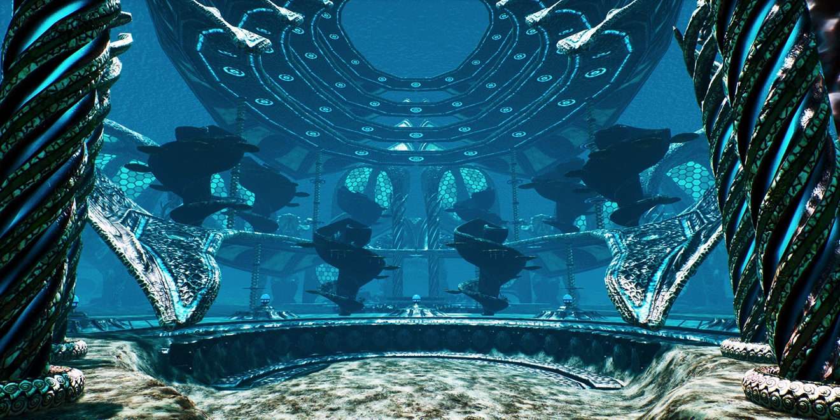

University of Human Seduction, where Mer learn how to seduce humans into loving nature, Lost City of Mer

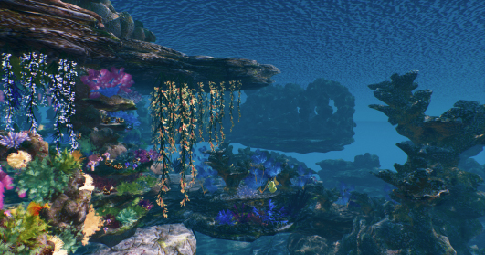

Secret Coral Garden, Lost City of Mer

